Project Planning
Project Planning Phase — Product Backlog, Sprint Planning, Stories, Story Points
Date | 15 February 2025
Team ID | SWTID-2026-1074
Project Name | SB Stocks
Team Size | 5
Team Leader | Venkatesh Illa
Team Members | Durga Meghana Kondempudi, Chandrika Narla, Mogali Shyam, Sravani Jagu
Maximum Marks | 5 Marks

Product Backlog & Sprint Schedule
Sprint | Functional Requirement (Epic) | USN | User Story / Task | Story Points | Priority | Team Member
Sprint-1 | Registration | USN-1 | As a user, I can register for the application by entering my username, email, user type and password. | 2 | High | Venkatesh Illa
Sprint-1 | Registration | USN-2 | As a user, my password is securely hashed with bcrypt before it is stored. | 1 | High | Durga Meghana Kondempudi
Sprint-1 | Login | USN-3 | As a user, I can log in and receive a JWT token to access protected pages. | 2 | High | Chandrika Narla
Sprint-1 | Dashboard | USN-4 | As a user, I can view trending/live-simulated stocks on my Home dashboard. | 2 | High | Mogali Shyam
Sprint-2 | Trading | USN-5 | As a user, I can place a Buy order and see my wallet balance and holdings update instantly. | 3 | High | Sravani Jagu
Sprint-2 | Trading | USN-6 | As a user, I can place a Sell order for shares I currently hold. | 3 | High | Venkatesh Illa
Sprint-2 | Wallet | USN-7 | As a user, I can deposit/withdraw virtual funds and see it reflected in my transaction history. | 2 | High | Durga Meghana Kondempudi
Sprint-3 | Portfolio & History | USN-8 | As a user, I can view my portfolio holdings and full order/transaction history. | 2 | Medium | Chandrika Narla

Project Tracker, Velocity & Burndown
Sprint | Total Story Points | Duration | Start Date | End Date (Planned) | Story Points Completed | Release Date (Actual)
Sprint-1 | 7 | 6 Days | 01 Jun 2026 | 06 Jun 2026 | 7 | 06 Jun 2026
Sprint-2 | 8 | 6 Days | 08 Jun 2026 | 13 Jun 2026 | 8 | 13 Jun 2026
Sprint-3 | 2 | 6 Days | 15 Jun 2026 | 20 Jun 2026 | 2 | 20 Jun 2026
Sprint-4 | 3 | 6 Days | 22 Jun 2026 | 27 Jun 2026 | 3 | 27 Jun 2026
Across the four sprints, the team planned and completed 20 story points on schedule, taking SB Stocks from registration and login through trading, wallet management, and portfolio/history features.

Burndown Chart
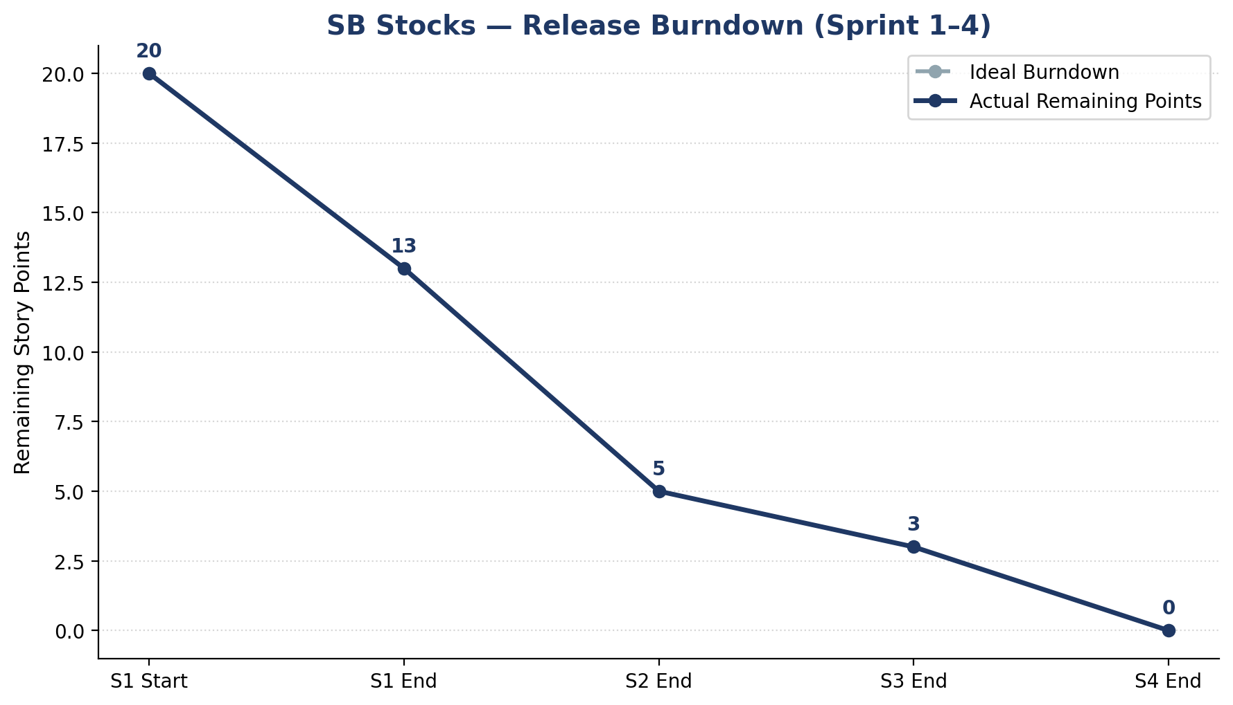
Figure: SB Stocks release burndown across Sprint 1–4, story points remaining vs. ideal pace

